**RIPHAH INTERNATIONAL**

**UNIVERSITY, ISLAMABAD**



**Lab#6**

**Bachelors of Computer Science – 6th Semester**

**Subject: Artificial Intelligence**

Submitted to: Ms. **Ayesha Akram**

Submitted by: Ayiza Waqar

Sap id : 44529

Date of Submission: 3/11/2025

**TASK 1**

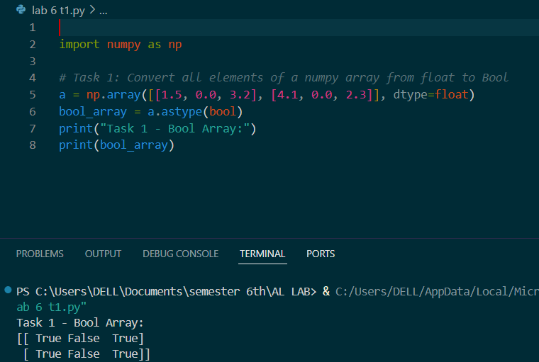

**TASK 2**

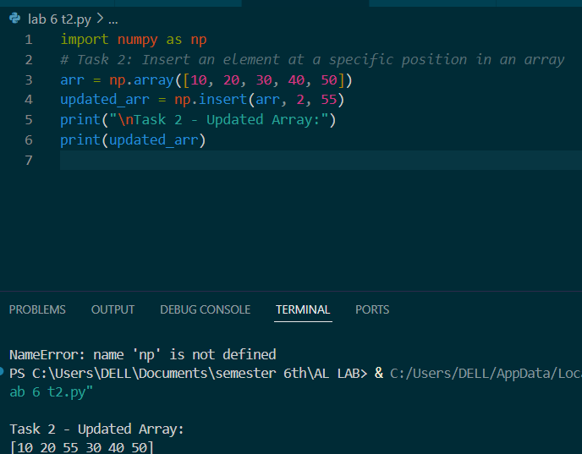

**TASK 3**

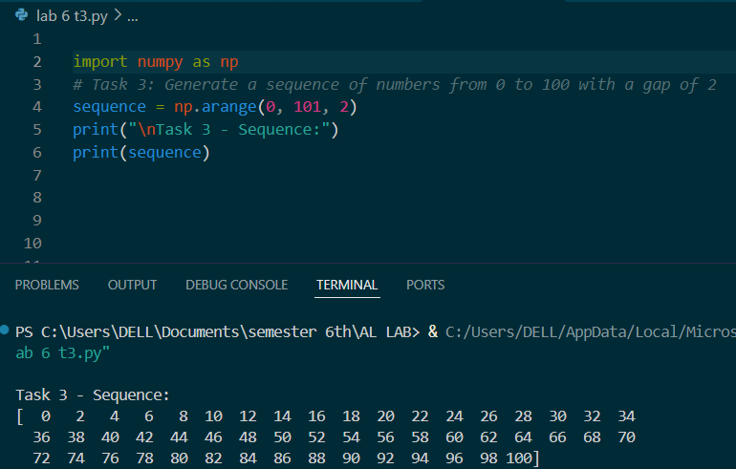

**TASK 4**

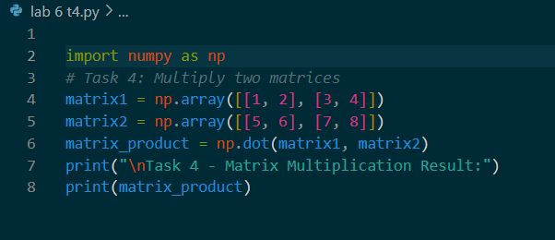

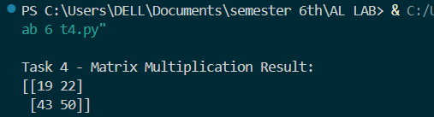

**TASK 5**

